**Project Design Phase-II**

**Data Flow Diagram & User Stories**

|  |  |
| --- | --- |
| Date | 24 June 2025 |
| Team ID | LTVIP2025TMID53161 |
| Project Name | SB Foods - On-Demand Food Ordering Platform |
| Maximum Marks | 4 Marks |

**Data Flow Diagrams:**

A Data Flow Diagram (DFD) is a traditional visual representation of the information flows within a system. A neat and clear DFD can depict the right amount of the system requirement graphically. It shows how data enters and leaves the system, what changes the information, and where data is stored.

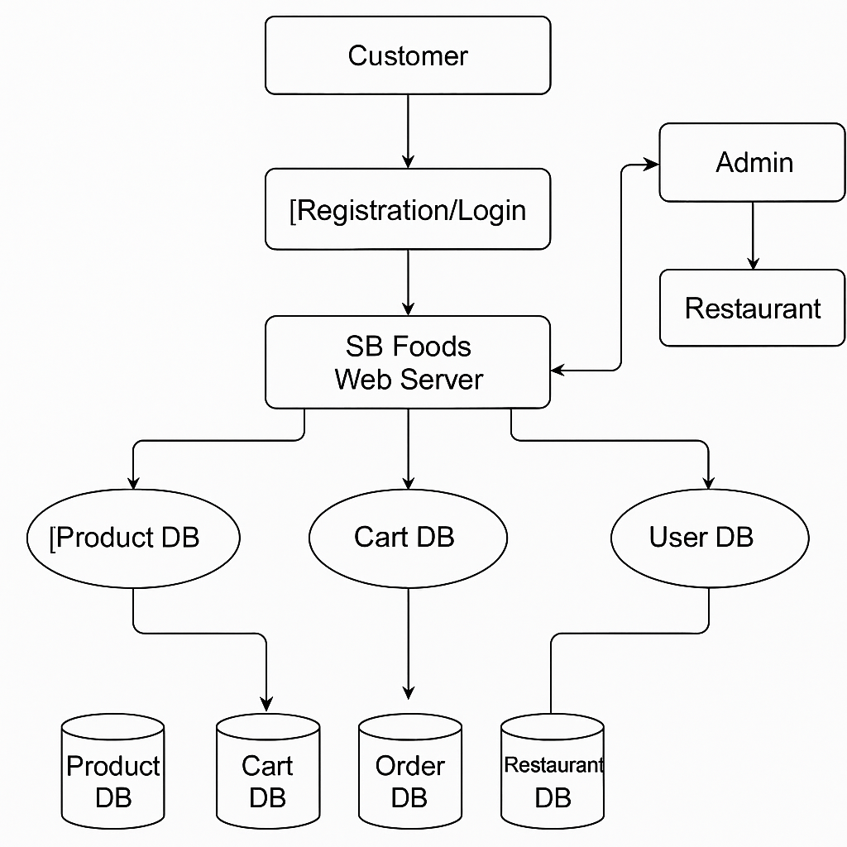

**Key Flows:**

* Customer → Registration/Login → System → Stores in User DB
* Customer → Browse Products → View from Product DB
* Customer → Cart → Cart DB → Place Order → Order DB
* Admin → View Users/Orders → Manage DB
* Restaurant → Login → Add/Edit Products → Product DB

**User Stories**

|  |  |  |  |  |  |  |
| --- | --- | --- | --- | --- | --- | --- |
| **User Type** | **Functional Requirement (Epic)** | **User Story Number** | **User Story / Task** | **Acceptance Criteria** | **Priority** | **Release** |
| Customer (Mobile) | Registration | USN-1 | As a user, I can register for the application by entering my email, password, and confirming password. | I can access my account/dashboard | High | Sprint-1 |
|  |  | USN-2 | As a user, I will receive a confirmation email once I have registered. | I can receive confirmation email and click confirm | High | Sprint-1 |
|  |  | USN-3 | As a user, I can register via Facebook. | I can register and access dashboard using Facebook | Low | Sprint-2 |
|  |  | USN-4 | As a user, I can register via Gmail. | I can register and access dashboard using Gmail | Medium | Sprint-1 |
|  | Login | USN-5 | As a user, I can log in with email and password. | I can enter credentials and see my dashboard | High | Sprint-1 |
|  | Dashboard | USN-6 | As a user, I can view available food items with filters. | I can view food listings by category or restaurant | High | Sprint-1 |
|  | Cart | USN-7 | As a user, I can add items to my cart. | Items appear in cart and quantity can be changed | High | Sprint-2 |
|  | Orders | USN-8 | As a user, I can place an order and get confirmation. | Order is submitted and stored in DB; user gets confirmation | High | Sprint-2 |
| Restaurant | Authentication | USN-9 | As a restaurant, I can log in to my dashboard. | Successful login with restaurant credentials | High | Sprint-1 |
|  | Product Management | USN-10 | As a restaurant, I can add/edit/delete my food listings. | My listings are updated and saved properly | High | Sprint-2 |
|  | Orders | USN-11 | As a restaurant, I can view orders placed on my menu. | Orders are visible and filterable by status/date | Medium | Sprint-2 |
| Administrator | Admin Login | USN-12 | As an admin, I can log in with secure credentials. | Successful login to admin dashboard | High | Sprint-1 |
|  | Manage Users | USN-13 | As an admin, I can view and manage all user accounts. | I can deactivate/delete accounts and see activity logs | Medium | Sprint-2 |
|  | Approve Restaurants | USN-14 | As an admin, I can approve or reject restaurant registrations. | Approved restaurants can start listing | High | Sprint-2 |
|  | Reports | USN-15 | As an admin, I can generate order, product, and user reports. | I can download/view analytical summaries | Medium | Sprint-3 |